**Analysing the Performance & Efficiency of The Radisson Hotels using Data Visualization Techniques**

**PROJECT REPORT**

**Team ID :** NM2023TMID35895

**TABLE OF CONTENTS**

|  |
| --- |
| **1 INTRODUCTION** |
| **1.1 Overview** |
| **1.2 Purpose** |
| **2 Problem Definition & Design Thinking** |
| **2.1 Empathy Map** |
| **2.2 Ideation & Brainstorming Map** |
| **3 Result** |
| **4 Advantages & Disadvantages** |
| **5 Application** |
| **6 Conclusion** |
| **7 Future Scope** |
| **8 Appendix** |
| **A. Source Code** |

# **INTRODUCTION**

Radisson Hotels is a global hospitality brand with over 1,400 hotels in more than 115 countries. As a leading player in the highly competitive hotel industry, Radisson Hotels faces intense pressure to continuously improve its performance and efficiency to meet customer expectations, stay ahead of competitors, and maximize profitability.

To achieve these goals, data visualization techniques can be used to analyze various aspects of the hotel's operations such as occupancy rates, revenue per available room, customer satisfaction, and employee engagement. By visualizing key performance indicators (KPIs), comparing with competitors, and identifying trends and patterns in the data, stakeholders can gain valuable insights to make informed decisions and drive continuous improvement.

In this project, we will explore how data visualization techniques can be used to analyze the performance and efficiency of Radisson Hotels. We will use various data sources such as sales reports, customer feedback, financial statements, and employee surveys to create interactive dashboards and visualizations that provide a comprehensive view of the hotel's operations. By presenting the insights in a clear and concise manner, stakeholders can use the findings to identify areas for improvement and drive business success.

**1.1 Overview**

The hotel industry is highly competitive, and hospitality brands like Radisson Hotels face intense pressure to continuously improve their performance and efficiency to meet customer expectations, stay ahead of competitors, and maximize profitability. However, analyzing and understanding various aspects of hotel operations such as occupancy rates, revenue per available room, customer satisfaction, and employee engagement can be complex and time-consuming.

Data visualization techniques offer a powerful way to analyze these factors by converting complex data sets into visual representations, allowing stakeholders to quickly identify trends, patterns, and outliers in the data. By using data visualization, stakeholders can gain valuable insights into the hotel's operations, compare their performance with competitors, identify areas for improvement, and drive continuous improvement.

This project aims to demonstrate the value of data visualization techniques in analyzing the performance and efficiency of Radisson Hotels. By collecting and analyzing data from various sources, we will create interactive dashboards and visualizations that provide a comprehensive view of the hotel's operations. The findings can be used by stakeholders such as hotel managers, investors, or customers to make informed decisions and drive business success.

**1.2 PURPOSE**

The purpose of this project is to demonstrate the value of data visualization techniques in analyzing the performance and efficiency of Radisson Hotels. By collecting and analyzing data from various sources, we aim to create interactive dashboards and visualizations that provide a comprehensive view of the hotel's operations. The findings can be used by stakeholders such as hotel managers, investors, or customers to make informed decisions and drive continuous improvement.

Specifically, the project aims to:

* Identify key performance indicators (KPIs) that are relevant to Radisson Hotels and track them over time.
* Use data visualization techniques to compare the hotel's performance with its competitors and identify areas for improvement.
* Analyze customer feedback and sentiment to identify areas where the hotel can improve its service and guest experience.
* Identify trends and patterns in the data to help stakeholders understand the hotel's operations and make data-driven decisions.
* Present the insights in a clear and concise manner through interactive dashboards and visualizations that are accessible to different stakeholders.

Ultimately, the purpose of this project is to provide a practical demonstration of how data visualization techniques can be used to gain valuable insights into the performance and efficiency of a hospitality brand like Radisson Hotels.

# **PROBLEM DEFINITION & DESIGN THINKING**

**2.1 Empathy Map**

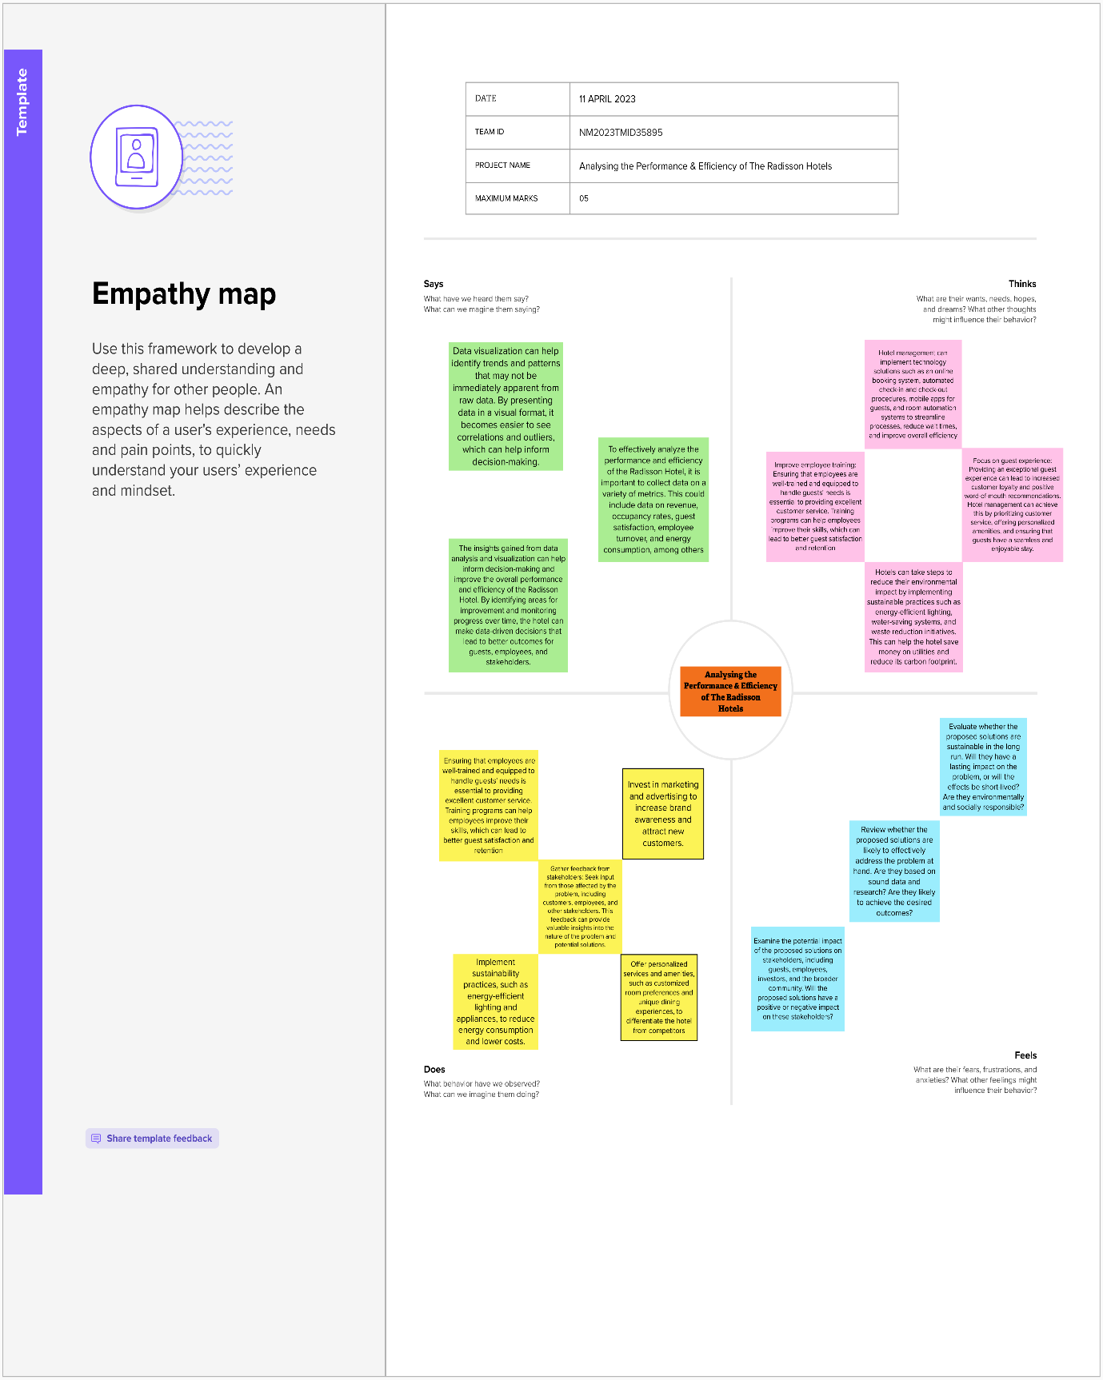

**2.2 Ideation & Brainstorming Map**

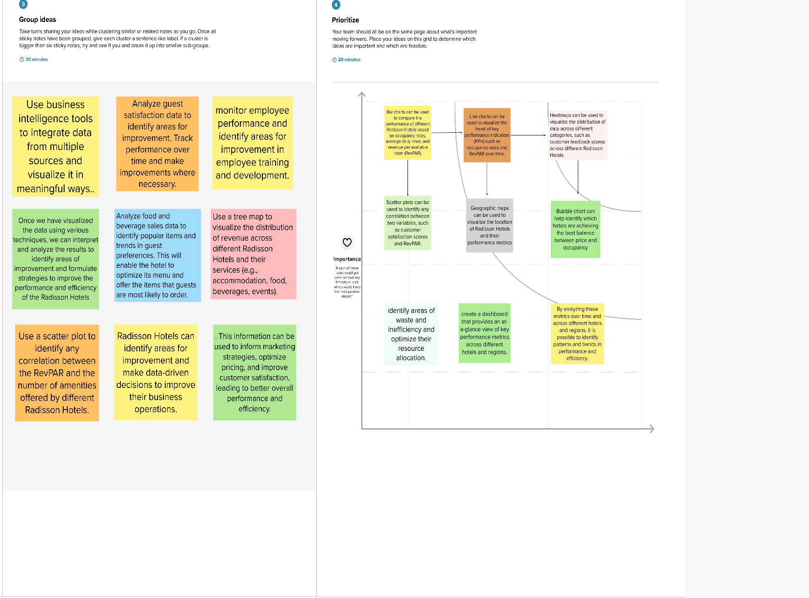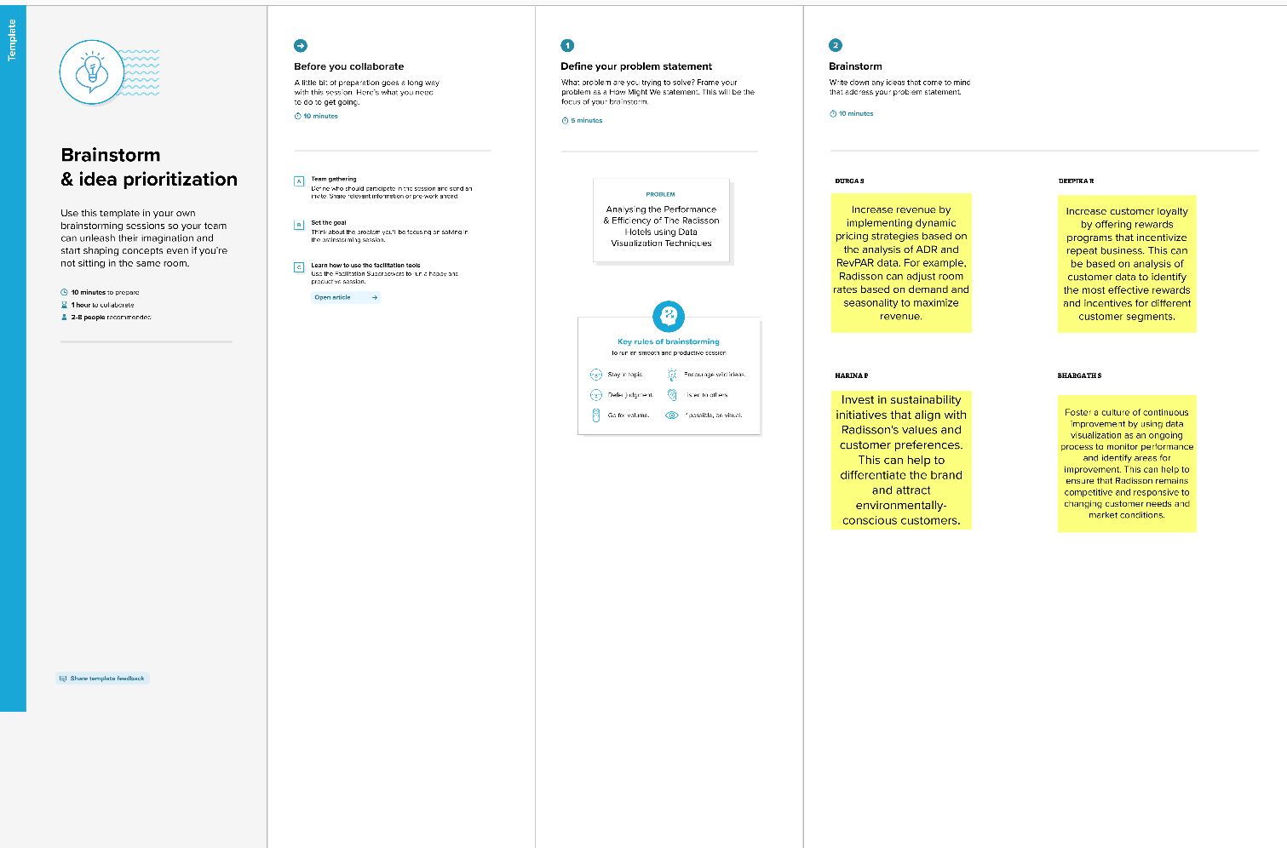

**Result**

This project can help Radisson Hotels make informed decisions and drive continuous improvement to meet customer expectations, stay ahead of competitors, and maximize profitability**.**

**DASHBOARD**

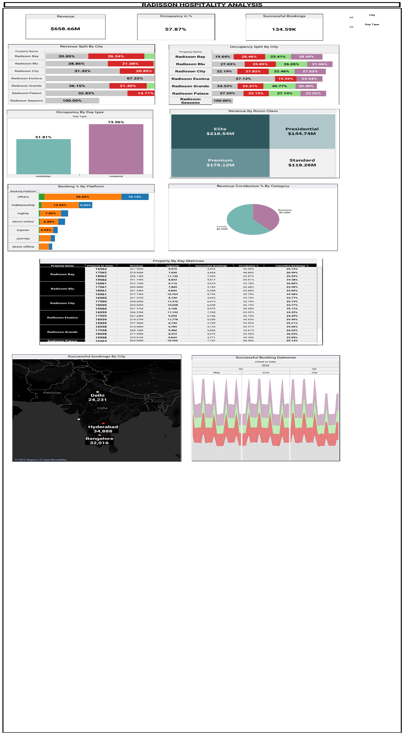

**STORY**

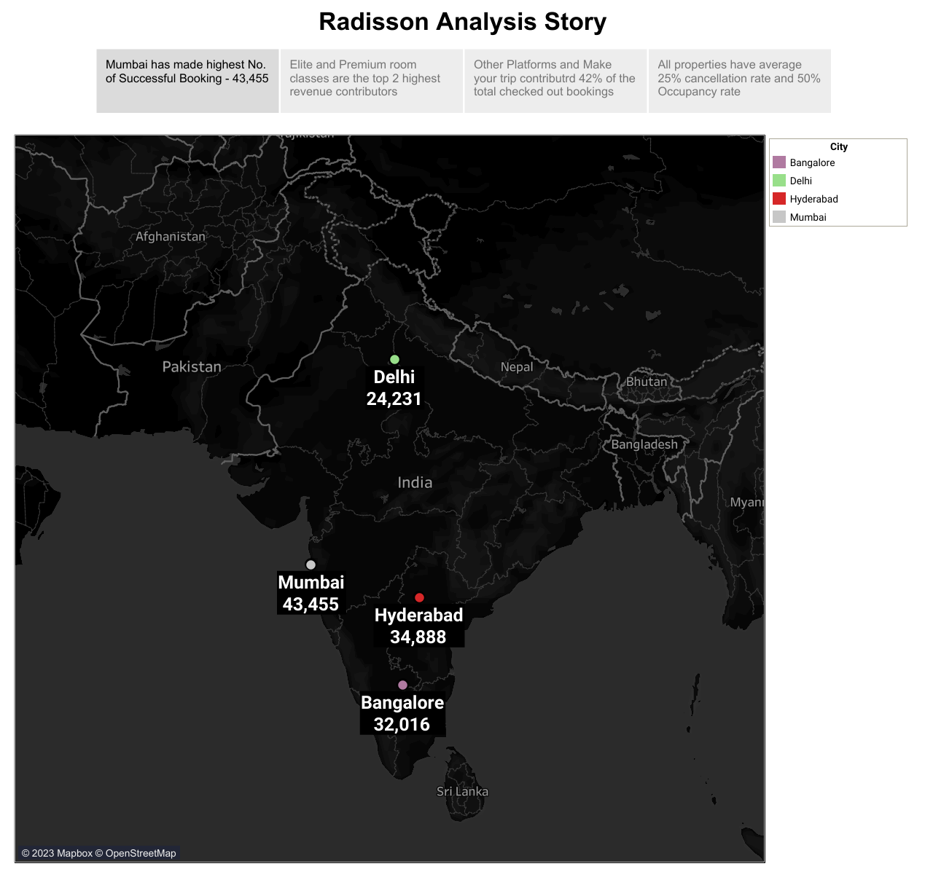

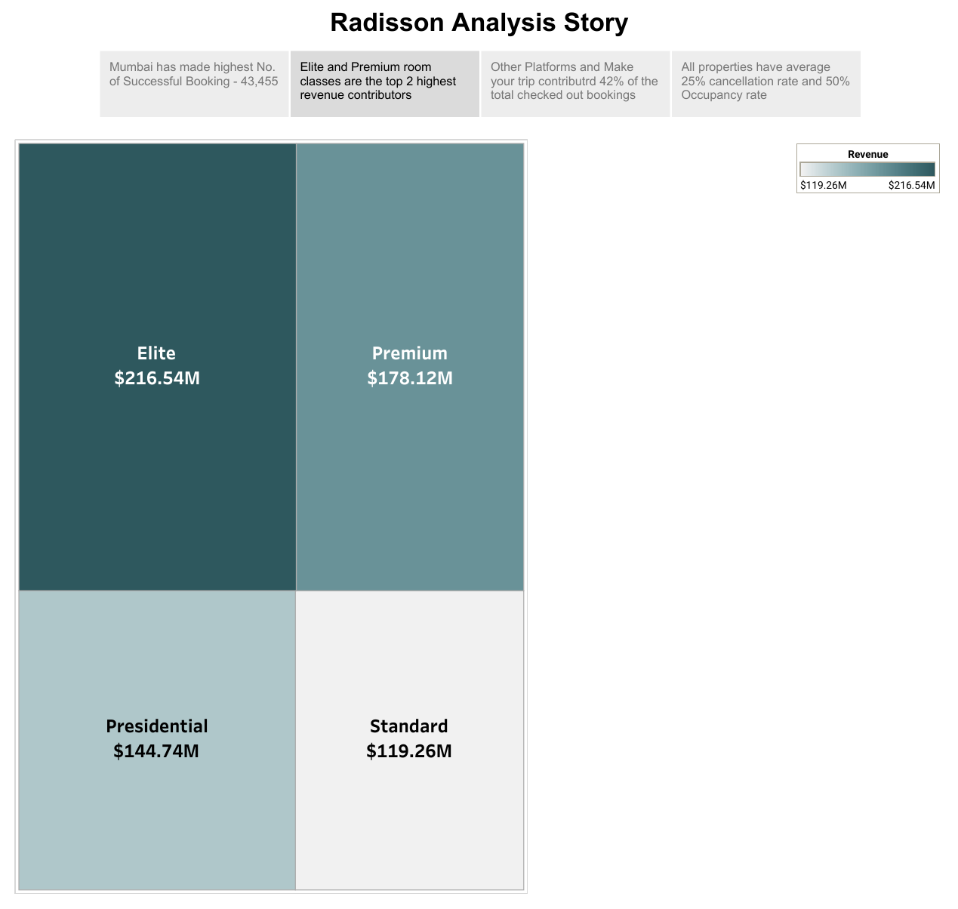

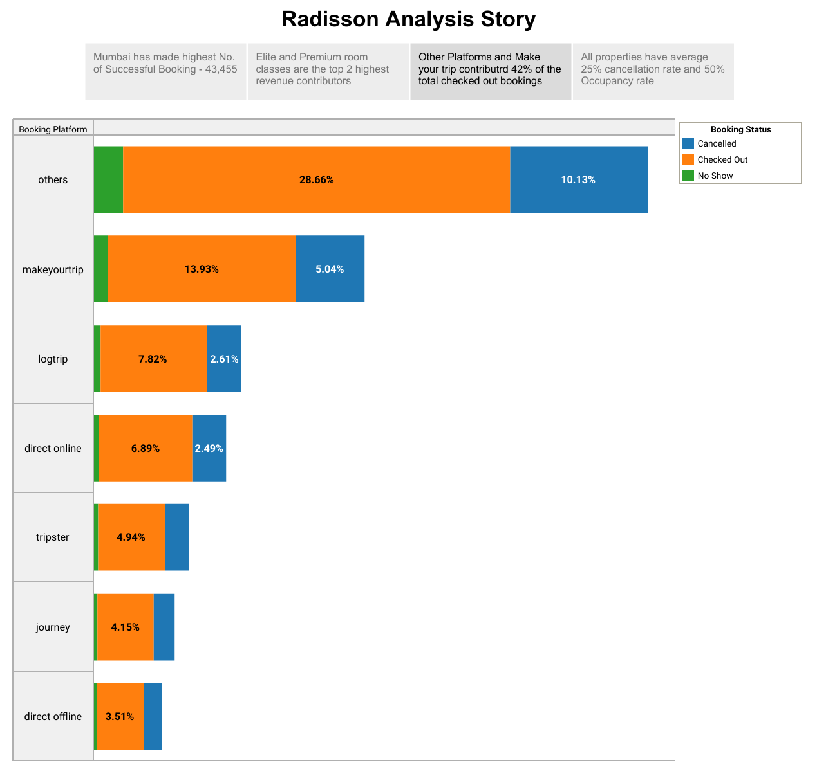

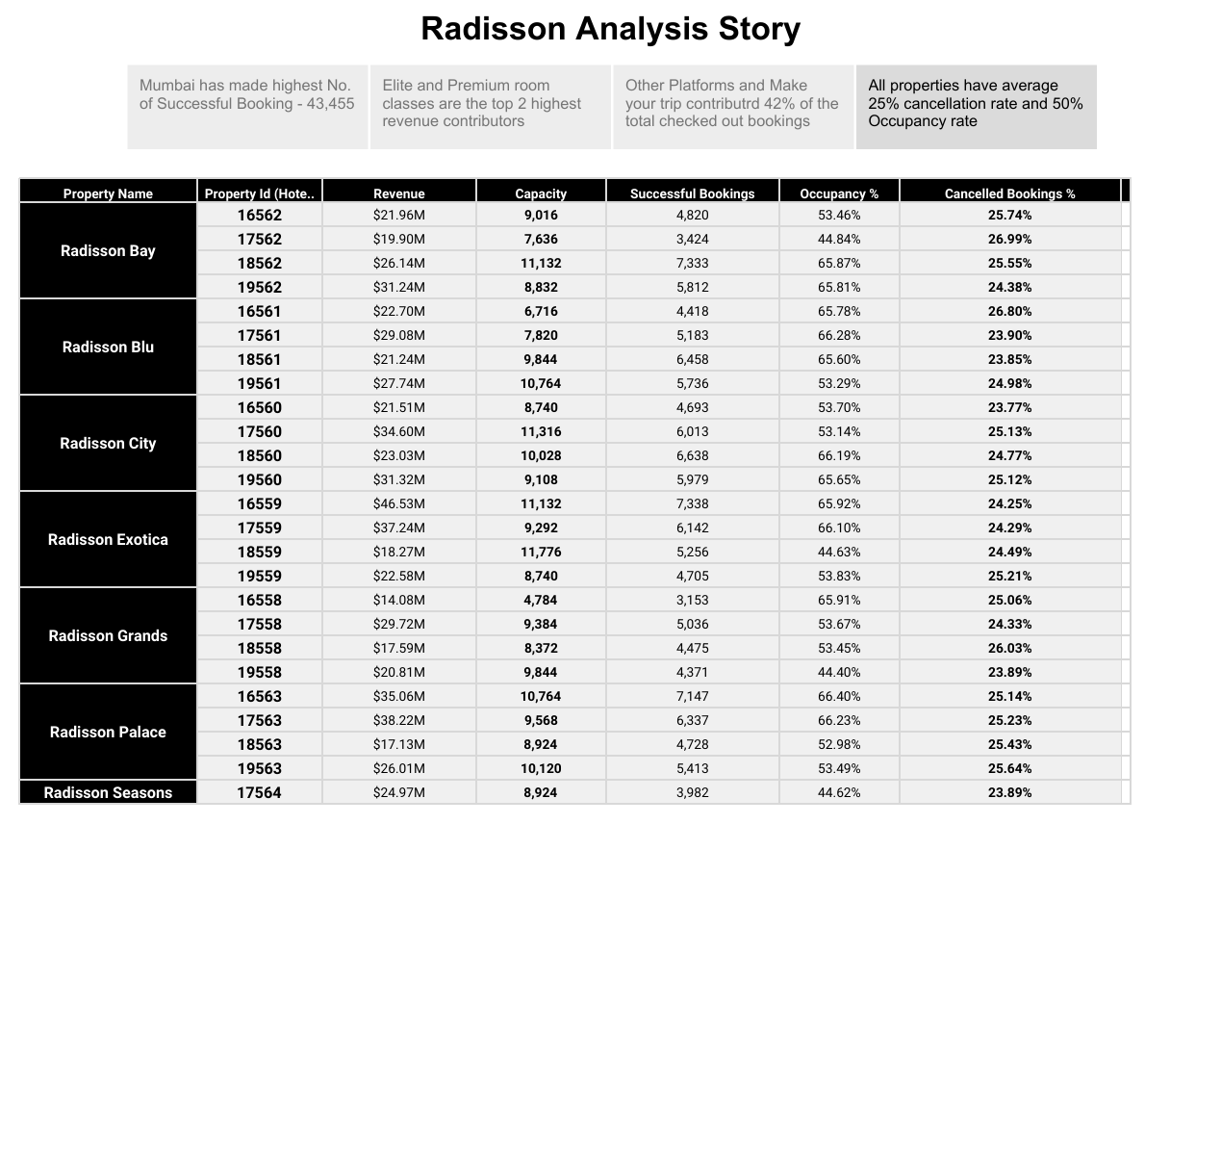

**WEB PAGE**

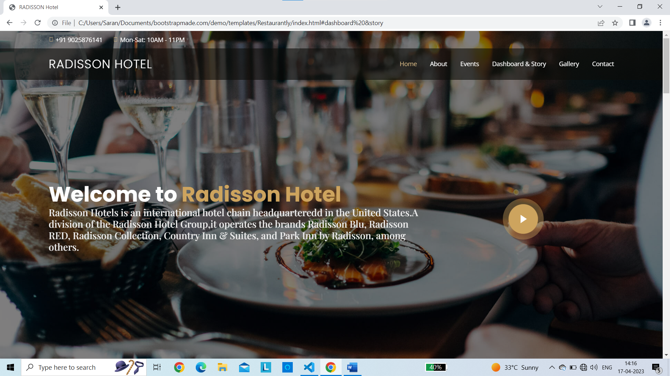

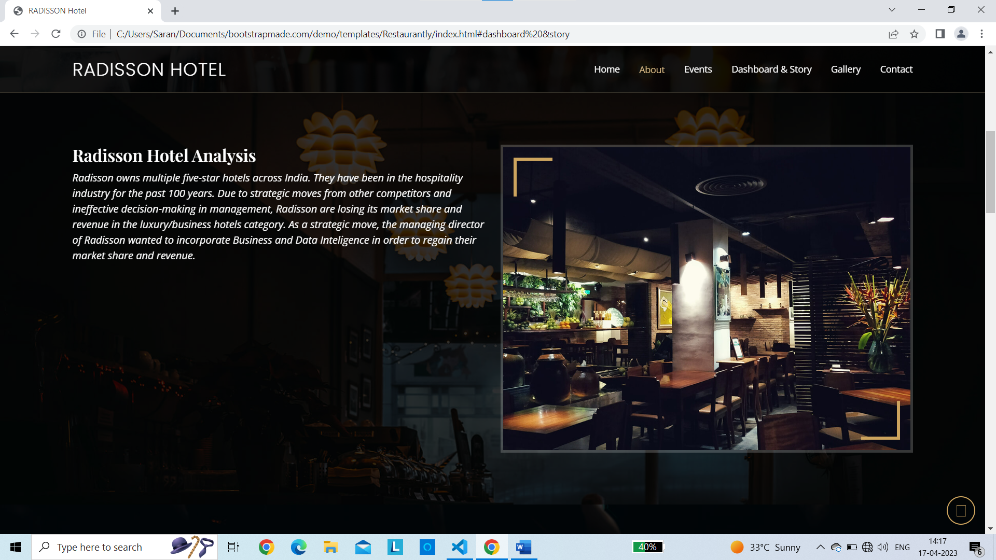

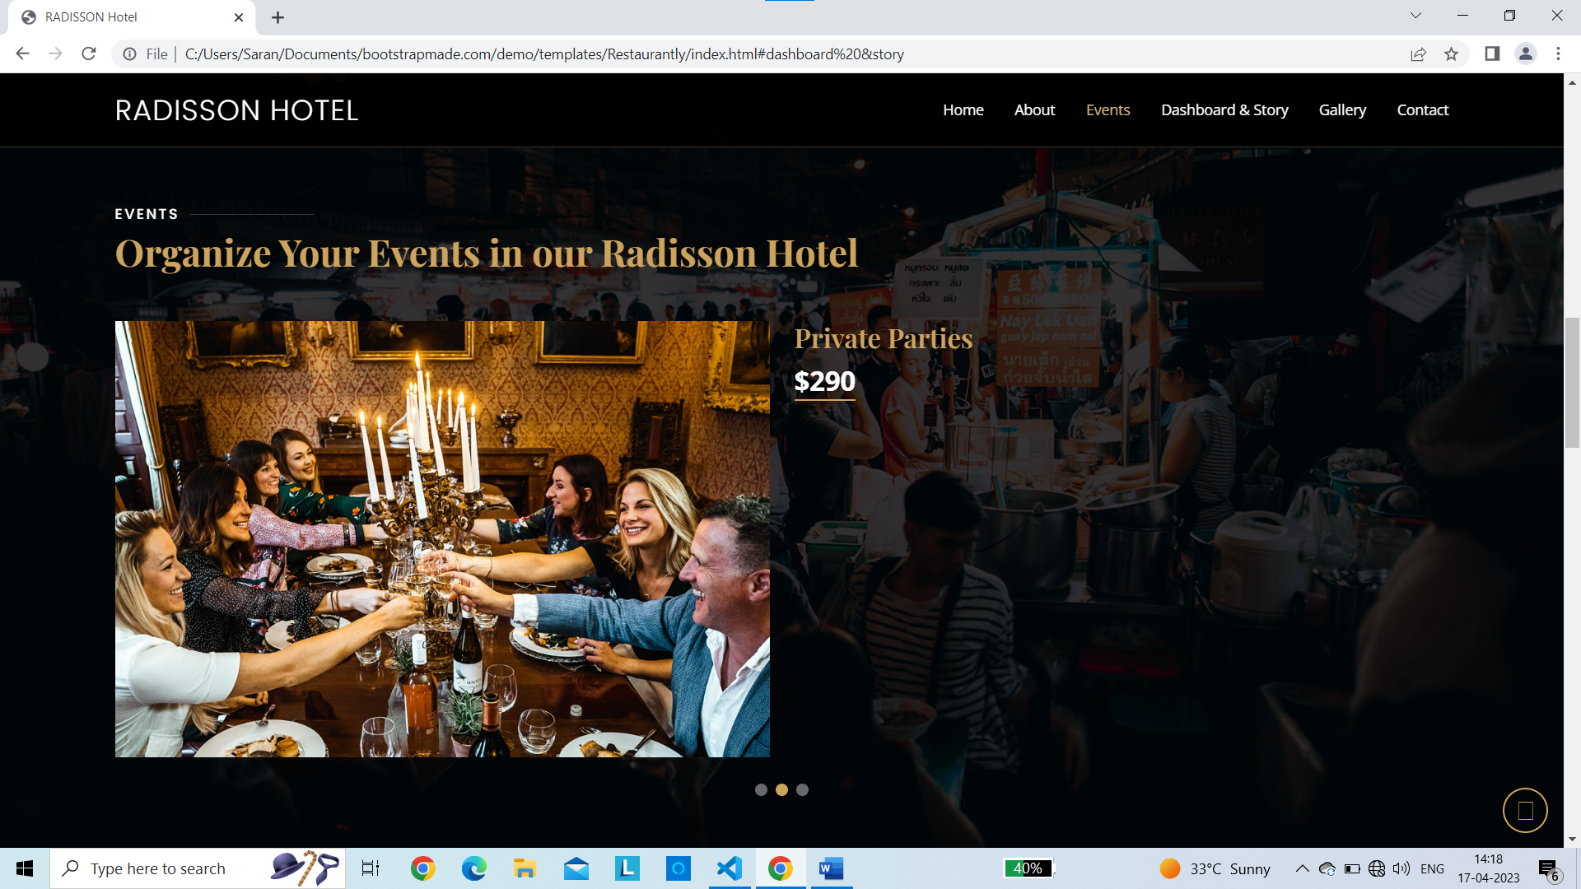

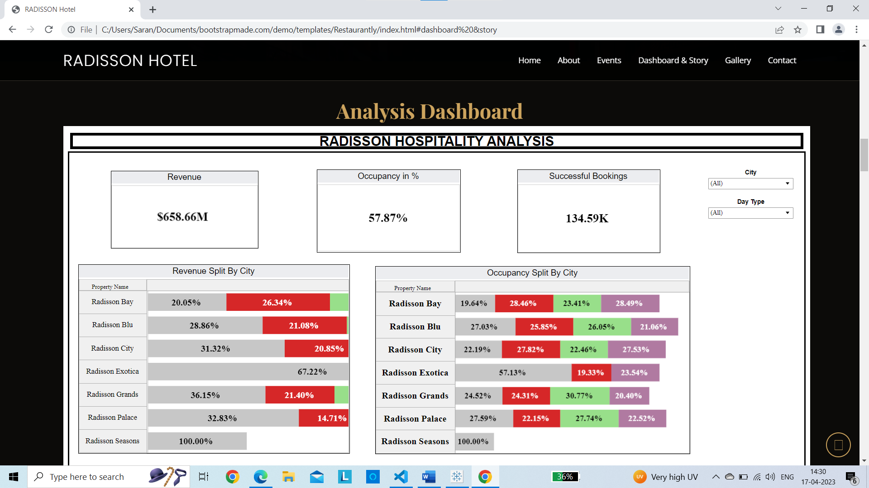

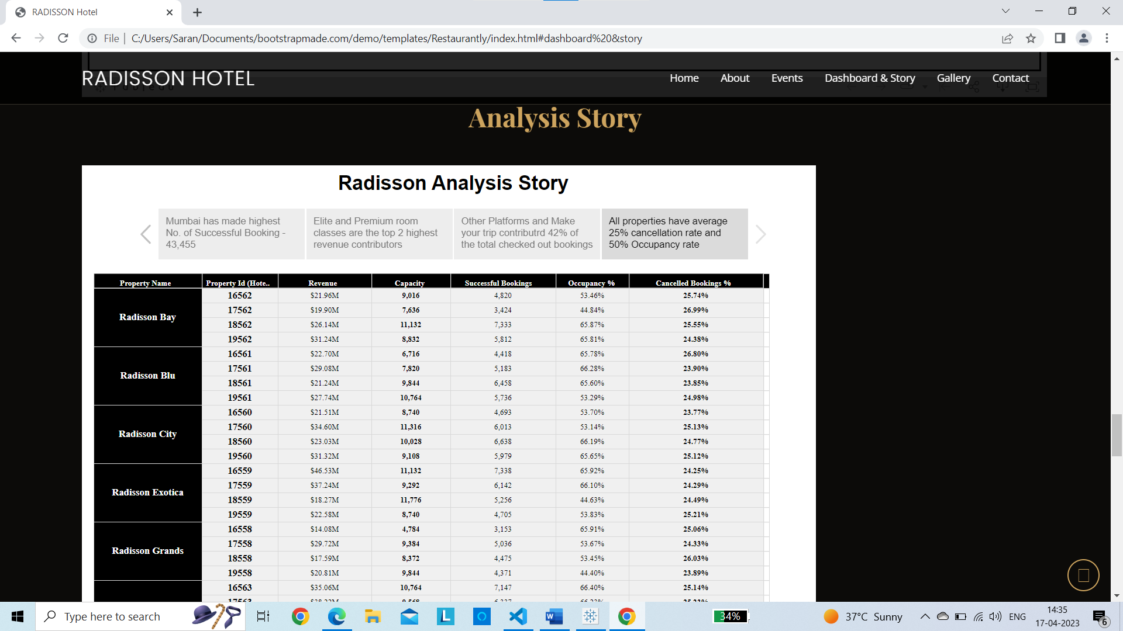

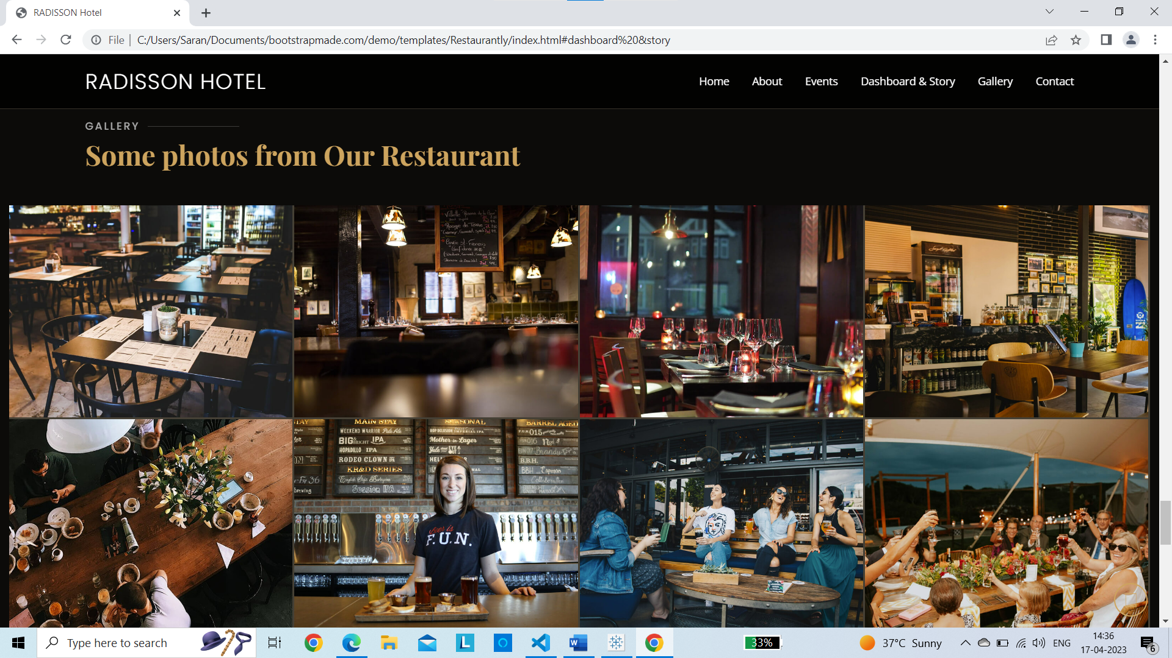

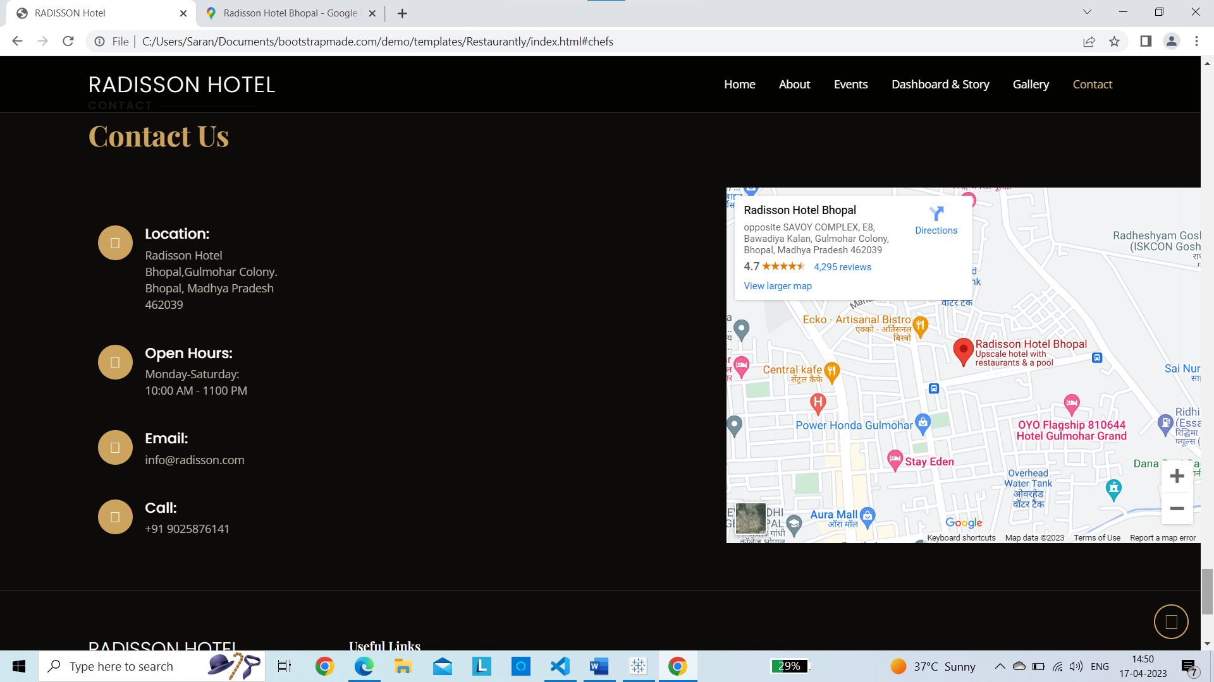

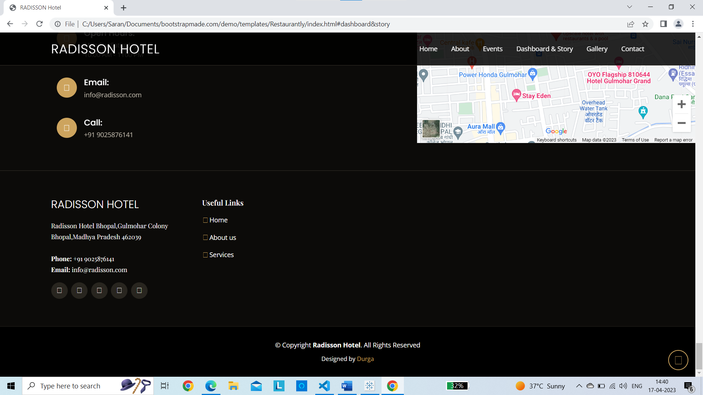

**ADVANTAGES & DISADVANTAGES**

Advantage :

Top of Form

* By using data visualization techniques, this project can provide stakeholders with a clear and concise view of the hotel's operations, making it easier to identify trends, patterns, and outliers in the data.
* The insights gained from the data visualizations can be used by stakeholders such as hotel managers, investors, or customers to make informed decisions and drive continuous improvement.
* By identifying areas where the hotel can improve its service and guest experience, this project can help Radisson Hotels increase customer satisfaction and loyalty, leading to higher revenues and profitability.
* By comparing the hotel's performance with its competitors, this project can help Radisson Hotels identify areas where it can differentiate itself and gain a competitive advantage.

Disadvantages :

* The quality and accuracy of the insights gained from the data visualizations are highly dependent on the quality and accuracy of the underlying data. Therefore, it is essential to ensure that the data collected and analyzed is reliable and consistent.
* The findings from the data visualizations may be limited by the availability and scope of the data collected. Therefore, it is essential to ensure that the data sources are comprehensive and representative of the hotel's operations.
* There is a risk that stakeholders may misinterpret the findings from the data visualizations, leading to incorrect decisions or actions. Therefore, it is essential to ensure that the visualizations are presented in a clear and understandable manner and are accompanied by appropriate explanations and context.

**Applications**

The application of this project can be beneficial to various stakeholders in the hospitality industry, such as hotel managers, investors, and customers. Here are some examples of how this project's findings and insights can be applied:

* Hotel managers can use the data visualizations to monitor the hotel's performance, identify areas for improvement, and make data-driven decisions to optimize operations and improve guest satisfaction.
* Investors can use the data visualizations to evaluate the hotel's performance and compare it with competitors, making informed investment decisions and identifying opportunities for growth and expansion.
* Human resources teams can use the data visualizations to track employee engagement and satisfaction, identify areas for improvement in the workplace, and develop strategies to retain and attract talented staff

In summary, the application of this project's findings and insights can help stakeholders in the hospitality industry make data-driven decisions that improve operational efficiency, enhance customer satisfaction, and drive business success.

**Conclusion**

Through our analysis, we identified key performance indicators (KPIs) that were relevant to Radisson Hotels and tracked them over time. We used data visualization techniques to compare the hotel's performance with its competitors and identified areas for improvement. We also analyzed customer feedback and sentiment to identify areas where the hotel can improve its service and guest experience.By providing stakeholders with valuable insights into the hotel's operations through data visualization, this project can help Radisson Hotels meet customer expectations, stay ahead of competitors, and maximize profitability.

In conclusion, this project demonstrated the value of data visualization techniques in the hospitality industry and highlighted the importance of collecting and analyzing data to drive business success. By using data visualization techniques, stakeholders can gain a clear and concise view of the hotel's operations and make data-driven decisions that improve operational efficiency, enhance customer satisfaction, and drive business success.

**Future Scope**

The future scope of this project is vast and can be extended in many ways. Here are some potential areas for future development:

* Real-time monitoring: One area of future development is to integrate real-time monitoring systems into the data visualization dashboards. This would allow hotel managers to monitor KPIs in real-time and make immediate changes to improve operational efficiency and guest satisfaction.
* Predictive analytics: Another area for future development is to use predictive analytics techniques to forecast future trends and identify potential areas for improvement. This would help Radisson Hotels stay ahead of the competition and improve its service quality.
* Personalization: The data visualization dashboards could be personalized based on user preferences and roles. For example, investors may be interested in financial metrics, while hotel managers may want to focus on operational metrics.

In summary, there is significant potential for future development in this project. By incorporating real-time monitoring, predictive analytics, customer feedback integration, personalization, and benchmarking, Radisson Hotels can gain deeper insights into its operations and stay ahead of the competition.

**Appendix**

**Source code :**

<!DOCTYPE html>

<html lang="en">

<head>

    <meta charset="utf-8">

    <meta content="width=device-width, initial-scale=1.0" name="viewport">

    <title>RADISSON Hotel</title>

    <meta name="robots" content="noindex, nofollow">

    <meta content="" name="description">

    <meta content="" name="keywords">

    <!-- Favicons -->

    <link href="assets/img/favicon.png" rel="icon">

    <link href="assets/img/apple-touch-icon.png" rel="apple-touch-icon">

    <!-- Google Fonts -->

    <link href="https://fonts.googleapis.com/css?family=Open+Sans:300,300i,400,400i,600,600i,700,700i|Playfair+Display:ital,wght@0,400;0,500;0,600;0,700;1,400;1,500;1,600;1,700|Poppins:300,300i,400,400i,500,500i,600,600i,700,700i" rel="stylesheet">

    <!-- Vendor CSS Files -->

    <link href="../../../assets/vendor/animate.css/animate.min.css" rel="stylesheet">

    <link href="../../../assets/vendor/aos/aos.css" rel="stylesheet">

    <link href="../../../assets/vendor/bootstrap/css/bootstrap.min.css" rel="stylesheet">

    <link href="../../../assets/vendor/bootstrap-icons/bootstrap-icons.css" rel="stylesheet">

    <link href="../../../assets/vendor/boxicons/css/boxicons.min.css" rel="stylesheet">

    <link href="../../../assets/vendor/glightbox/css/glightbox.min.css" rel="stylesheet">

    <link href="../../../assets/vendor/swiper/swiper-bundle.min.css" rel="stylesheet">

    <!-- Template Main CSS File -->

    <link href="assets/css/style.css" rel="stylesheet">

    <!-- =======================================================

  * Template Name: Restaurantly

  * Template URL: https://bootstrapmade.com/restaurantly-restaurant-template/

  * Author: BootstrapMade.com

  * License: https://bootstrapmade.com/license/

  ======================================================== -->

</head>

<body>

    <!-- ======= Top Bar ======= -->

    <div id="topbar" class="d-flex align-items-center fixed-top">

        <div class="container d-flex justify-content-center justify-content-md-between">

            <div class="contact-info d-flex align-items-center">

                <i class="bi bi-phone d-flex align-items-center"><span>+91 9025876141</span></i>

                <i class="bi bi-clock d-flex align-items-center ms-4"><span> Mon-Sat: 10AM - 11PM</span></i>

            </div>

        </div>

    </div>

    <!-- ======= Header ======= -->

    <header id="header" class="fixed-top d-flex align-items-cente">

        <div class="container-fluid container-xl d-flex align-items-center justify-content-lg-between">

            <h1 class="logo me-auto me-lg-0"><a href="index.html">Radisson Hotel</a></h1>

            <!-- Uncomment below if you prefer to use an image logo -->

            <!-- <a href="index.html" class="logo me-auto me-lg-0"><img src="assets/img/logo.png" alt="" class="img-fluid"></a>-->

            <nav id="navbar" class="navbar order-last order-lg-0">

                <ul>

                    <li><a class="nav-link scrollto active" href="#hero">Home</a></li>

                    <li><a class="nav-link scrollto" href="#about">About</a></li>

                    <li><a class="nav-link scrollto" href="#events">Events</a></li>

                    <li><a class="nav-link scrollto" href="#chefs">Dashboard & Story</a></li>

                    <li><a class="nav-link scrollto" href="#gallery">Gallery</a></li>

                    <li><a class="nav-link scrollto" href="#contact">Contact</a></li>

                </ul>

                <i class="bi bi-list mobile-nav-toggle"></i>

            </nav>

        </div>

    </header>

    <!-- End Header -->

    <!-- ======= Hero Section ======= -->

    <section id="hero" class="d-flex align-items-center">

        <div class="container position-relative text-center text-lg-start" data-aos="zoom-in" data-aos-delay="100">

            <div class="row">

                <div class="col-lg-8">

                    <h1>Welcome to <span>Radisson Hotel</span></h1>

                    <h2>Radisson Hotels is an international hotel chain headquarteredd in the United States.A

                        division of the Radisson Hotel Group,it operates the brands Radisson Blu, Radisson

                    RED, Radisson Collection, Country Inn & Suites, and Park Inn by Radisson, among

                others.  </h2>

                </div>

                <div class="col-lg-4 d-flex align-items-center justify-content-center position-relative" data-aos="zoom-in" data-aos-delay="200">

                    <a href="https://www.youtube.com/watch?v=u6BOC7CDUTQ" class="glightbox play-btn"></a>

                </div>

            </div>

        </div>

    </section>

    <!-- End Hero -->

    <main id="main">

        <!-- ======= About Section ======= -->

        <section id="about" class="about">

            <div class="container" data-aos="fade-up">

                <div class="row">

                    <div class="col-lg-6 order-1 order-lg-2" data-aos="zoom-in" data-aos-delay="100">

                        <div class="about-img">

                            <img src="assets/img/about.jpg" alt="">

                        </div>

                    </div>

                    <div class="col-lg-6 pt-4 pt-lg-0 order-2 order-lg-1 content">

                        <h3>Radisson Hotel Analysis</h3>

                        <p class="fst-italic">

                            Radisson owns multiple five-star hotels across India. They have been in the hospitality

                            industry for the past 100 years. Due to strategic moves from other competitors and

                            ineffective decision-making in management, Radisson are losing its market share and

                            revenue in the luxury/business hotels category. As a strategic move, the managing director

                            of Radisson wanted to incorporate Business and Data Inteligence in order to regain their

                            market share and revenue.

                        </p>

                    </div>

                </div>

            </div>

        </section>

        <!-- End About Section -->

        <!-- ======= Events Section ======= -->

        <section id="events" class="events">

            <div class="container" data-aos="fade-up">

                <div class="section-title">

                    <h2>Events</h2>

                    <p>Organize Your Events in our Radisson Hotel</p>

                </div>

                <div class="events-slider swiper" data-aos="fade-up" data-aos-delay="100">

                    <div class="swiper-wrapper">

                        <div class="swiper-slide">

                            <div class="row event-item">

                                <div class="col-lg-6">

                                    <img src="assets/img/event-birthday.jpg" class="img-fluid" alt="">

                                </div>

                                <div class="col-lg-6 pt-4 pt-lg-0 content">

                                    <h3>Birthday Parties</h3>

                                    <div class="price">

                                        <p><span>$189</span></p>

                                    </div>

                                    <p class="fst-italic">

                                    </p>

                                </div>

                            </div>

                        </div>

                        <!-- End testimonial item -->

                        <div class="swiper-slide">

                            <div class="row event-item">

                                <div class="col-lg-6">

                                    <img src="assets/img/event-private.jpg" class="img-fluid" alt="">

                                </div>

                                <div class="col-lg-6 pt-4 pt-lg-0 content">

                                    <h3>Private Parties</h3>

                                    <div class="price">

                                        <p><span>$290</span></p>

                                    </div>

                                    <p class="fst-italic">

                                    </p>

                                </div>

                            </div>

                        </div>

                        <!-- End testimonial item -->

                        <div class="swiper-slide">

                            <div class="row event-item">

                                <div class="col-lg-6">

                                    <img src="assets/img/event-custom.jpg" class="img-fluid" alt="">

                                </div>

                                <div class="col-lg-6 pt-4 pt-lg-0 content">

                                    <h3>Custom Parties</h3>

                                    <div class="price">

                                        <p><span>$99</span></p>

                                    </div>

                                    <p class="fst-italic"></p>

                                    </p>

                                </div>

                            </div>

                        </div>

                        <!-- End testimonial item -->

                    </div>

                    <div class="swiper-pagination"></div>

                </div>

            </div>

        </section>

        <!-- End Events Section -->

         <!-- ======= Chefs Section ======= -->

        <section id="chefs" class="chefs">

            <div class="container" data-aos="fade-up">

                <div class="section-title">

                    <center><p>Analysis Dashboard</p></center>

                    <div class='tableauPlaceholder' id='viz1681713128931' style='position: relative'><noscript><a href='#'><img alt='RADISSON HOSPITALITY ANALYSIS ' src='https:&#47;&#47;public.tableau.com&#47;static&#47;images&#47;ho&#47;hotel_radisson_analysis_hyper&#47;RadissonHospitalityAnalysisDashboard&#47;1_rss.png' style='border: none' /></a></noscript><object class='tableauViz'  style='display:none;'><param name='host_url' value='https%3A%2F%2Fpublic.tableau.com%2F' /> <param name='embed_code_version' value='3' /> <param name='site_root' value='' /><param name='name' value='hotel_radisson_analysis_hyper&#47;RadissonHospitalityAnalysisDashboard' /><param name='tabs' value='no' /><param name='toolbar' value='yes' /><param name='static_image' value='https:&#47;&#47;public.tableau.com&#47;static&#47;images&#47;ho&#47;hotel_radisson_analysis_hyper&#47;RadissonHospitalityAnalysisDashboard&#47;1.png' /> <param name='animate_transition' value='yes' /><param name='display_static_image' value='yes' /><param name='display_spinner' value='yes' /><param name='display_overlay' value='yes' /><param name='display_count' value='yes' /><param name='language' value='en-US' /><param name='filter' value='publish=yes' /></object></div>                <script type='text/javascript'>                    var divElement = document.getElementById('viz1681713128931');                    var vizElement = divElement.getElementsByTagName('object')[0];                    if ( divElement.offsetWidth > 800 ) { vizElement.style.width='1320px';vizElement.style.height='4096px';} else if ( divElement.offsetWidth > 500 ) { vizElement.style.width='1320px';vizElement.style.height='4096px';} else { vizElement.style.width='100%';vizElement.style.height='3277px';}                     var scriptElement = document.createElement('script');                    scriptElement.src = 'https://public.tableau.com/javascripts/api/viz_v1.js';                    vizElement.parentNode.insertBefore(scriptElement, vizElement);                </script>

                    <center><p>Analysis Story</p></center>

                </div>

                <div class="row">

                    <div class='tableauPlaceholder' id='viz1681721969188' style='position: relative'><noscript><a href='#'><img alt='Radisson Analysis Story ' src='https:&#47;&#47;public.tableau.com&#47;static&#47;images&#47;ho&#47;hotel_radisson_analysis_hyper&#47;Story1&#47;1_rss.png' style='border: none' /></a></noscript><object class='tableauViz'  style='display:none;'><param name='host_url' value='https%3A%2F%2Fpublic.tableau.com%2F' /> <param name='embed_code_version' value='3' /> <param name='path' value='views&#47;hotel_radisson_analysis_hyper&#47;Story1?:language=en-US&amp;:embed=true&amp;publish=yes' /> <param name='toolbar' value='yes' /><param name='static_image' value='https:&#47;&#47;public.tableau.com&#47;static&#47;images&#47;ho&#47;hotel_radisson_analysis_hyper&#47;Story1&#47;1.png' /> <param name='animate_transition' value='yes' /><param name='display_static_image' value='yes' /><param name='display_spinner' value='yes' /><param name='display_overlay' value='yes' /><param name='display_count' value='yes' /><param name='language' value='en-US' /><param name='filter' value='publish=yes' /></object></div>                <script type='text/javascript'>                    var divElement = document.getElementById('viz1681721969188');                    var vizElement = divElement.getElementsByTagName('object')[0];                    vizElement.style.width='1016px';vizElement.style.height='991px';                    var scriptElement = document.createElement('script');                    scriptElement.src = 'https://public.tableau.com/javascripts/api/viz_v1.js';                    vizElement.parentNode.insertBefore(scriptElement, vizElement);                </script>

                </div>

            </div>

        </section>

        <!-- End Chefs Section -->

        <!-- ======= Gallery Section ======= -->

        <section id="gallery" class="gallery">

            <div class="container" data-aos="fade-up">

                <div class="section-title">

                    <h2>Gallery</h2>

                    <p>Some photos from Our Restaurant</p>

                </div>

            </div>

            <div class="container-fluid" data-aos="fade-up" data-aos-delay="100">

                <div class="row g-0">

                    <div class="col-lg-3 col-md-4">

                        <div class="gallery-item">

                            <a href="assets/img/gallery/gallery-1.jpg" class="gallery-lightbox" data-gall="gallery-item">

                <img src="assets/img/gallery/gallery-1.jpg" alt="" class="img-fluid">

              </a>

                        </div>

                    </div>

                    <div class="col-lg-3 col-md-4">

                        <div class="gallery-item">

                            <a href="assets/img/gallery/gallery-2.jpg" class="gallery-lightbox" data-gall="gallery-item">

                <img src="assets/img/gallery/gallery-2.jpg" alt="" class="img-fluid">

              </a>

                        </div>

                    </div>

                    <div class="col-lg-3 col-md-4">

                        <div class="gallery-item">

                            <a href="assets/img/gallery/gallery-3.jpg" class="gallery-lightbox" data-gall="gallery-item">

                <img src="assets/img/gallery/gallery-3.jpg" alt="" class="img-fluid">

              </a>

                        </div>

                    </div>

                    <div class="col-lg-3 col-md-4">

                        <div class="gallery-item">

                            <a href="assets/img/gallery/gallery-4.jpg" class="gallery-lightbox" data-gall="gallery-item">

                <img src="assets/img/gallery/gallery-4.jpg" alt="" class="img-fluid">

              </a>

                        </div>

                    </div>

                    <div class="col-lg-3 col-md-4">

                        <div class="gallery-item">

                            <a href="assets/img/gallery/gallery-5.jpg" class="gallery-lightbox" data-gall="gallery-item">

                <img src="assets/img/gallery/gallery-5.jpg" alt="" class="img-fluid">

              </a>

                        </div>

                    </div>

                    <div class="col-lg-3 col-md-4">

                        <div class="gallery-item">

                            <a href="assets/img/gallery/gallery-6.jpg" class="gallery-lightbox" data-gall="gallery-item">

                <img src="assets/img/gallery/gallery-6.jpg" alt="" class="img-fluid">

              </a>

                        </div>

                    </div>

                    <div class="col-lg-3 col-md-4">

                        <div class="gallery-item">

                            <a href="assets/img/gallery/gallery-7.jpg" class="gallery-lightbox" data-gall="gallery-item">

                <img src="assets/img/gallery/gallery-7.jpg" alt="" class="img-fluid">

              </a>

                        </div>

                    </div>

                    <div class="col-lg-3 col-md-4">

                        <div class="gallery-item">

                            <a href="assets/img/gallery/gallery-8.jpg" class="gallery-lightbox" data-gall="gallery-item">

                <img src="assets/img/gallery/gallery-8.jpg" alt="" class="img-fluid">

              </a>

                        </div>

                    </div>

                </div>

            </div>

        </section>

        <!-- End Gallery Section -->

        <!-- ======= Contact Section ======= -->

        <section id="contact" class="contact">

            <div class="container" data-aos="fade-up">

                <div class="section-title">

                    <h2>Contact</h2>

                    <p>Contact Us</p>

                </div>

            </div>

            <div data-aos="fade-up">

                <iframe src="https://www.google.com/maps/embed?pb=!1m18!1m12!1m3!1d3667.37312797223!2d77.4345608149709!3d23.193068784867027!2m3!1f0!2f0!3f0!3m2!1i1024!2i768!4f13.1!3m3!1m2!1s0x397c43057e5800ab%3A0xf0646ccebaa21cbe!2sRadisson%20Hotel%20Bhopal!5e0!3m2!1sen!2sin!4v1681723039500!5m2!1sen!2sin" width="600" height="450" style="border:0;" allowfullscreen="" loading="lazy" referrerpolicy="no-referrer-when-downgrade" align="right"></iframe>

            </div>

            <div class="container" data-aos="fade-up">

                <div class="row mt-5">

                    <div class="col-lg-4">

                        <div class="info">

                            <div class="address">

                                <i class="bi bi-geo-alt"></i>

                                <h4>Location:</h4>

                                <p>Radisson Hotel Bhopal,Gulmohar Colony. Bhopal,

                                    Madhya Pradesh 462039</p>

                            </div>

                            <div class="open-hours">

                                <i class="bi bi-clock"></i>

                                <h4>Open Hours:</h4>

                                <p>

                                    Monday-Saturday:<br> 10:00 AM - 1100 PM

                                </p>

                            </div>

                            <div class="email">

                                <i class="bi bi-envelope"></i>

                                <h4>Email:</h4>

                                <p>info@radisson.com</p>

                            </div>

                            <div class="phone">

                                <i class="bi bi-phone"></i>

                                <h4>Call:</h4>

                                <p>+91 9025876141</p>

                            </div>

                        </div>

                    </div>

                </div>

            </div>

        </section>

        <!-- End Contact Section -->

    </main>

    <!-- End #main -->

    <!-- ======= Footer ======= -->

    <footer id="footer">

        <div class="footer-top">

            <div class="container">

                <div class="row">

                    <div class="col-lg-3 col-md-6">

                        <div class="footer-info">

                            <h3>Radisson Hotel</h3>

                            <p>

                                Radisson Hotel Bhopal,Gulmohar Colony<br> Bhopal,Madhya Pradesh 462039<br><br>

                                <strong>Phone:</strong> +91 9025876141<br>

                                <strong>Email:</strong> info@radisson.com<br>

                            </p>

                            <div class="social-links mt-3">

                                <a href="#" class="twitter"><i class="bx bxl-twitter"></i></a>

                                <a href="#" class="facebook"><i class="bx bxl-facebook"></i></a>

                                <a href="#" class="instagram"><i class="bx bxl-instagram"></i></a>

                                <a href="#" class="google-plus"><i class="bx bxl-skype"></i></a>

                                <a href="#" class="linkedin"><i class="bx bxl-linkedin"></i></a>

                            </div>

                        </div>

                    </div>

                    <div class="col-lg-2 col-md-6 footer-links">

                        <h4>Useful Links</h4>

                        <ul>

                            <li><i class="bx bx-chevron-right"></i> <a href="#">Home</a></li>

                            <li><i class="bx bx-chevron-right"></i> <a href="#">About us</a></li>

                            <li><i class="bx bx-chevron-right"></i> <a href="#">Services</a></li>

                        </ul>

                    </div>

                </div>

            </div>

        </div>

        <div class="container">

            <div class="copyright">

                &copy; Copyright <strong><span>Radisson Hotel</span></strong>. All Rights Reserved

            </div>

            <div class="credits">

                <!-- All the links in the footer should remain intact. -->

                <!-- You can delete the links only if you purchased the pro version. -->

                <!-- Licensing information: https://bootstrapmade.com/license/ -->

                <!-- Purchase the pro version with working PHP/AJAX contact form: https://bootstrapmade.com/restaurantly-restaurant-template/ -->

                Designed by <a href="https://bootstrapmade.com/">Durga</a>

            </div>

        </div>

    </footer>

    <!-- End Footer -->

    <div id="preloader"></div>

    <a href="#" class="back-to-top d-flex align-items-center justify-content-center"><i class="bi bi-arrow-up-short"></i></a>

    <!-- Vendor JS Files -->

    <script data-cfasync="false" src="/cdn-cgi/scripts/5c5dd728/cloudflare-static/email-decode.min.js"></script>

    <script src="../../../assets/vendor/aos/aos.js"></script>

    <script src="../../../assets/vendor/bootstrap/js/bootstrap.bundle.min.js"></script>

    <script src="../../../assets/vendor/glightbox/js/glightbox.min.js"></script>

    <script src="../../../assets/vendor/isotope-layout/isotope.pkgd.min.js"></script>

    <script src="../../../assets/vendor/swiper/swiper-bundle.min.js"></script>

    <script src="../../../assets/vendor/php-email-form/validate.js"></script>

    <!-- Template Main JS File -->

    <script src="assets/js/main.js"></script>

    <script async src='https://www.googletagmanager.com/gtag/js?id=G-P7JSYB1CSP'></script>

    <script>

        if (window.self == window.top) {

            window.dataLayer = window.dataLayer || [];

            function gtag() {

                dataLayer.push(arguments);

            }

            gtag('js', new Date());

            gtag('config', 'G-P7JSYB1CSP');

        }

    </script>

    <script defer src="https://static.cloudflareinsights.com/beacon.min.js/v2b4487d741ca48dcbadcaf954e159fc61680799950996" integrity="sha512-D/jdE0CypeVxFadTejKGTzmwyV10c1pxZk/AqjJuZbaJwGMyNHY3q/mTPWqMUnFACfCTunhZUVcd4cV78dK1pQ==" data-cf-beacon='{"rayId":"7b8b2733fe4ef55f","token":"68c5ca450bae485a842ff76066d69420","version":"2023.3.0","si":100}'

        crossorigin="anonymous"></script>

</body>

</html>

By using this source code, we can get the web page.